****Unit 3

**60**

Essential Mathematics Test 1

Measurement

|  |  |
| --- | --- |
| **Name** |  |

* **Attempt all questions**
* **Show all working and calculations where possible**
* **Calculators are allowed**
* **One A4 page of notes is allowed**

***You must include all working out to receive full marks***

**1. Convert to the units specified. (8 Marks)**

1. 15 cm to ________ m e) 1m2 to ____________ cm2
2. 3.15 m to ________ mm f) 385cm2 to ____________ mm2
3. 25cm2 to ____________ mm2 g) 0.056 m2 to ____________mm2
4. 1km2 to ______________ cm2 h) 3125mm2 to _____________ m2

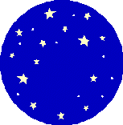**2. The diameter of this circular placemat is 25cm.  Find the circumference to 2 decimal places (2 Marks)**

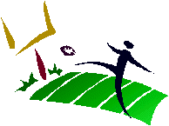

3. **A rectangular football field has side lines 100m long.  Each of the end lines is 50m long.  What is the perimeter of the football field? (2 Marks)**

**4. Calculate the area of the following shapes to 2 decimal places. (2,2,2,2,3 Marks)**

4 cm

a) b)

4.5 cm

7.25 m

12.5 m

2.8 cm

c) d)

19cm

1.5cm

8 cm

18 cm

e) f)

12 cm

45 cm

5. **Calculate the area of the sectors below (12 Marks)**

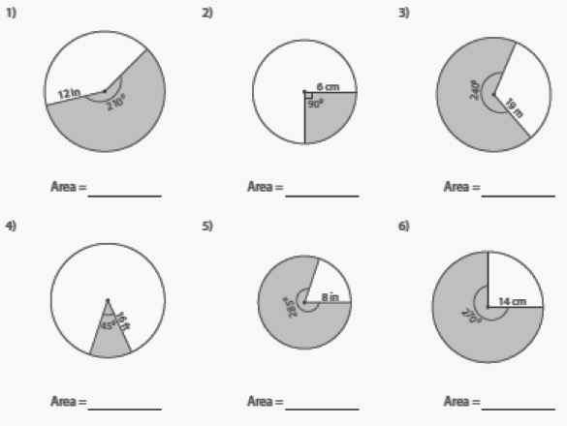

**6. Determine the area of the following shapes or shaded shapes. (3,4 marks)**

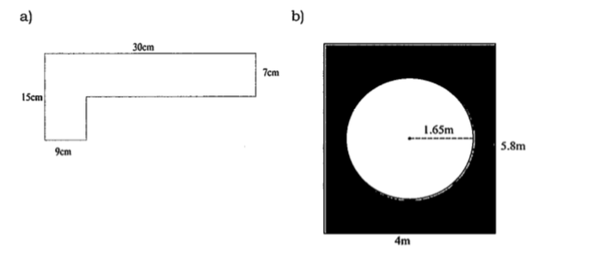

**7. Calculate the surface area of the shapes below. (3 ,3 ,2 Marks)**

**PLEASE SHOW ALL WORKING**

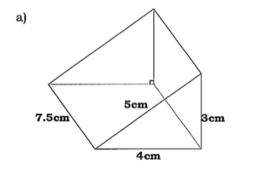

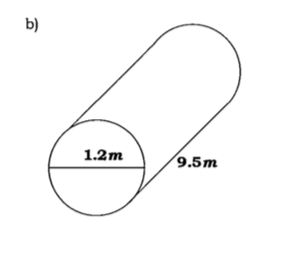

c)

0.12 m

13.5 cm

22 cm

**8. A box needs to be covered in brown paper for mailing.  If the box measures 3meters by 2 meters by 1.5 meters, what is the surface area of the box that will need to be covered assuming the box is closed? ( 3 Marks)**

**9. A soup can has a diameter of 8 cm and a height of 10.5 cm. How much metal is needed to make the can? ( 3 Marks)**

**10. For a project, Kenneth has to cover all sides of a rectangular based pyramid with cloth (excluding the base). The pyramid has the dimensions shown below. How much cloth will Kenneth need to cover the sides of the pyramid? ( 4 Marks)**

15cm

11cm

12cm